**Name: Shweta Jamdar**

**Rollno: TEAD-22521**

**DS (SL-III)**

**Practical 11**

**Problem Statement: Create databases and tables, insert small amounts of data, and run simple queries using Impala.**

**Code:**

**Pull the Impala Docker Image:**

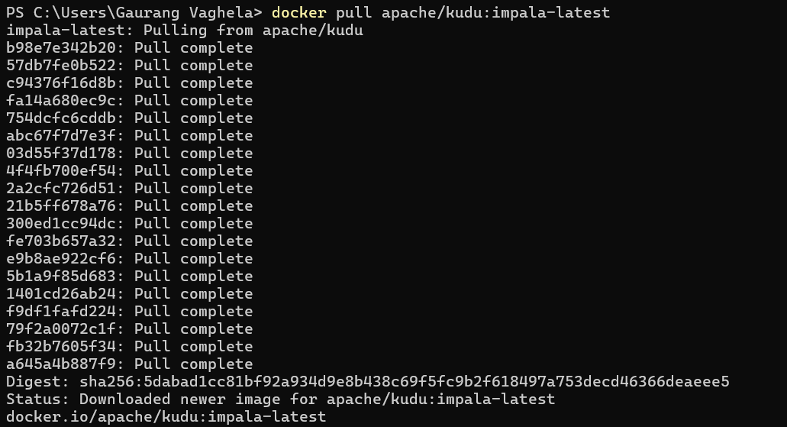

**Run the Impala Container:**



**Access the Impala Shell:**

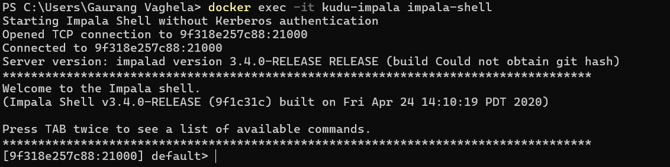

**Show Databases:**

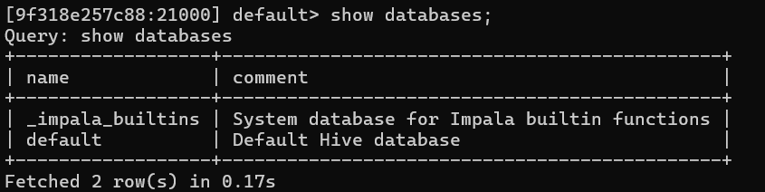

**Create Database and Table:**

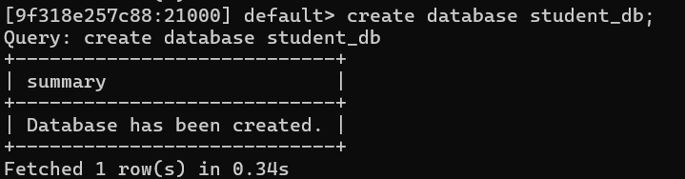

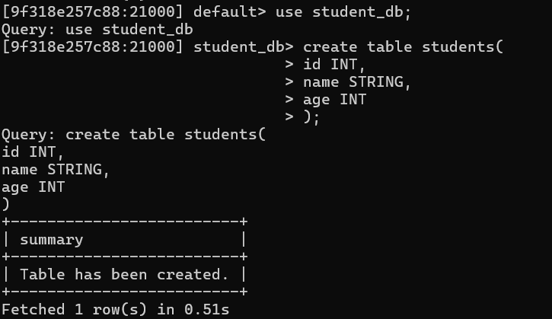

**Insert values in table:**

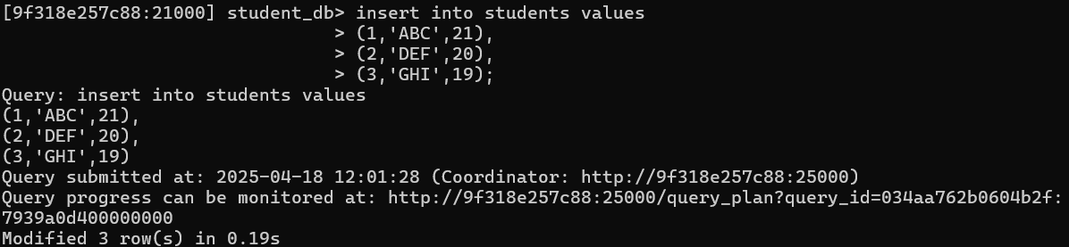

**Display Table:**

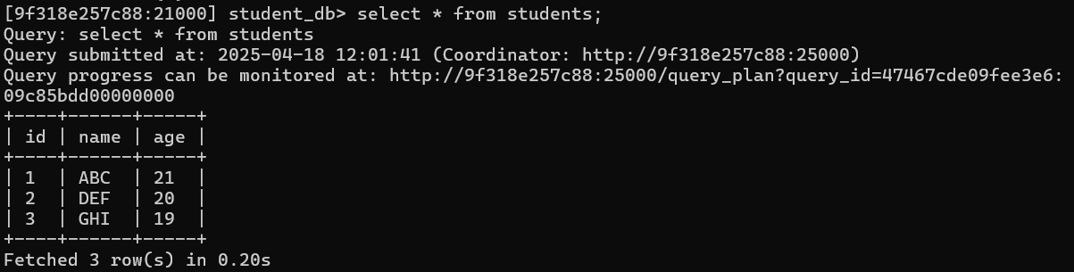

**Display Students where age > 20:**

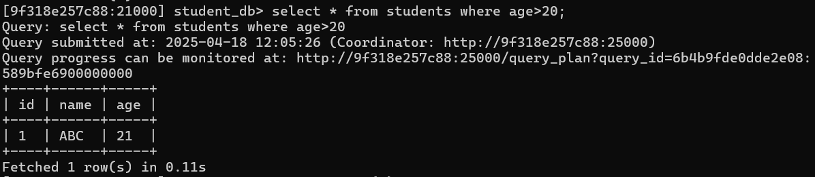

**Display Avg(age):**

